*You are receiving this email as a member of the media.*

*If you wish to unsubscribe from future messages, please reply with UNSUBSCRIBE in the subject line.*

**NEWS RELEASE**

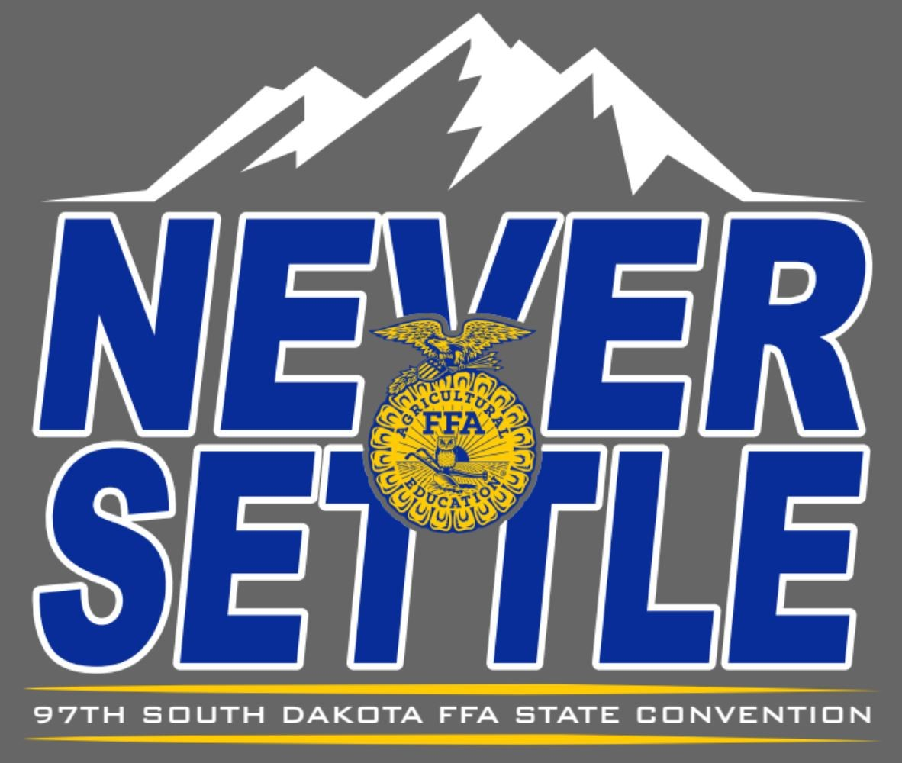

**South Dakota FFA Association**

|  |
| --- |
| Website: [www.sdaged.org](http://www.sdaged.org/) |
| Facebook: [www.facebook.com/South.Dakota.FFA](http://www.facebook.com/South.Dakota.FFA) |
| Instagram: @sdffaassociation |
|  |
| **For more information, contact:** |
| Caroline Hansen |
| South Dakota Leadership and Program Manager |
| Caroline.hansen@sdaged.org |

**FOR IMMEDIATE RELEASE**

April 8, 2025

**Photos of top 3 individuals and top team in each area are available to download at:** [**https://drive.google.com/drive/folders/1WwTqMPt57HZxqhufRrvMZg8BvIGXMopI**](https://drive.google.com/drive/folders/1WwTqMPt57HZxqhufRrvMZg8BvIGXMopI)

**Members Shine in FFA Career Development Events**

BROOKINGS, S.D. – FFA members are preparing for agriculture careers, learning the role agriculture plays in feeding and clothing the world, and looking for opportunities to grow the industry. FFA’s Career Development Events are built around ag industry careers, expose members to many of the opportunities and needs in the agriculture sector, and enable them to develop and refine their abilities to critically evaluate, effectively communicate and ultimately, succeed in future careers.

One of the hallmarks of agricultural education and the FFA is the opportunity to showcase skills learned in classrooms and spotlighted through competitive events. It is a source of pride and students look forward to the state-level events each year to determine who will represent South Dakota at the national level in the fall. This year 2,300 South Dakota FFA members competed in 15 Career Development Events at the State FFA Convention. Congrats to our state Career Development Event winners:

**Agricultural Business Management**

Awards are sponsored by Rufus and Patty DeZeeuw and the team travel scholarship is sponsored by Rufus & Patty DeZeeuw, FarmHouse Fraternity-SDSU, Leisinger Farm, and Kyle & Jody Peterson. Kyle & Jody Peterson also sponsored an iPad for the 1st place individual.

**1st place team:** Ethan; Advisor Susan Roudabush. Team members: Coltyn Raymond, Madisyn Raymond, William Kreth.

2nd: Willow Lake

3rd: Elkton

Top Individuals:

1. Brooklyn Boersma, Elkton
2. Coltyn Raymond, Ethan
3. Madisyn Raymond, Ethan

**Agricultural Technology and Mechanical Systems**

Awards and drills for each of the top 10 individuals sponsored by the CHS Foundation (pictured) and the team travel scholarship is sponsored by CHS Foundation, Grossenburg Implement, and the Ketelhut Family

**1st place team:** Brookings; Advisors Josh Johnson and Michelle Dykstra. Team members: Landin Tucker, Gabriel Stern, Tane Friedrich, Miles Gerlach

2nd: Sunshine Bible Academy

3rd: Harrisburg

Top Individuals:

1. Jackson Schlimmer, Sioux Valley
2. Cody Wiik, Milbank
3. Landin Tucker, Brookings

**Agronomy**

Awards are sponsored by Kurt (pictured) & Kathy Stiefvater and the team travel scholarship is sponsored by SD Agribusiness Association; the Croplan by WinField United; De & Mike Johnson in Memory of Walt Johnson; Hoegemeyer Hybrids; Simplot; Steven Zemlicka in Honor of Stan and Carol Gage

**1st place team:** McCook Central; Advisor Terry Rieckman. Team members: Kaylee Klinkhammer, Avery Alley, Karlie Stiefvater, Karlee Klinkhammer

2nd: Wessington Springs

3rd: Hot Springs

Top Individuals:

1. Robert Hine, Wessington Springs
2. Kaylee Klinkhammer, McCook Central
3. Briella Wettlaufer, Howard

**Dairy Cattle Evaluation**

Awards sponsored by SD Division of the Midwest Dairy Association and the team travel scholarship is sponsored by the Richard Lauck Family, Ash Grove Dairy, Sharp’s Inc. and Victory Farms.

**1st Place Team:** Beresford; Advisor Bridget Twedt. Team members: Elena Andrews, Grace Norling, Allie Westra, Capri Mullinix

2nd: Sioux Valley

3rd: McCook Central

Top Individuals:

1. Elena Andrews, Beresford
2. Brityn Davies, Lake Preston
3. Ava Couser, Brookings

**Floriculture**

Award are sponsored by Dr. David Graper, Wendy Mortenson Agency, and Gettysburg FFA and the team travel scholarship is sponsored by Dr. David Graper, Dan & Sheri Kahnke. Supplies for the event were sponsored by North American Wholesale Florists and the SD Florist Association.

**1st Place Team:** Brookings; Advisors Josh Johnson and Michelle Dykstra. Team members: Kenzie Steinhauer, Mikalyn Kelly, Madeline Enderson, Katie Marshall

2nd: Freeman

3rd: Parkston

Top Individuals:

1. Brylee Wallman, Miller
2. Ema Dissing, Tri-Valley
3. Whisper Apple, Garretson

**Food Science and Technology**

Awards sponsored by Valley Queen Cheese and the team travel scholarships are sponsored by Dan and Sheri Kahnke, Prairie Farms Cheese Division; Aurora Cooperative, Hunter Eide, Agropur Inc-Cheese and Whey Products.

**1st Place Team:** Harrisburg; Advisors Tara Fastert, Josh Christiansen, and Molly Roemen. Team members: Katelyn Wingert, Hannah Fryee, Leia Rombough, Isabelle Carlson

2nd: Belle Fourche

3rd: Freeman

Top Individuals:

1. Hunter Reede, Millbank
2. Katelyn Wingert, Harrisburg
3. Jazlyn Olson, Belle Fourche

**Horse Evaluation**

Awards are sponsored by K Bar J Leather of Newell. The travel scholarship is sponsored by K Bar J Leather, Rodney Yost Horsemanship, and Wendy Mortenson Agency.

**1st Place Team**: Brookings; Advisors Josh Johnson and Michelle Dykstra. Team members: Josie Nold, Aubrey Underwood, Ava Benson, Madelyn Myers

2nd: Parkston

3rd: Bon Homme

Top Individuals:

1. Josie Nold, Brookings
2. Bailey Schwagel, Milbank
3. Kenley Henke, Parkston

**Meats Evaluation:**

Awards are sponsored by Smithfield Foods and the travel scholarship is sponsored by Smithfield Foods, Tri Valley Alumni (Heidi Zwinger pictured) and The Meathouse.

**1st Place Team:** Brookings; Advisors Josh Johnson and Michelle Dykstra. Team members: Connor May, Kade Nelson, Ella Feucht, Carter Stadler

2nd: Tri-Valley

3rd: Hitchcock Tulare

Top Individuals:

1. Connor May, Brookings
2. Kade Nelson, Brookings
3. Kendall Mcarbavey, Tri-Valley

**Livestock Evaluation:**

Awards are sponsored by SD Pork Producers Council. The travel scholarship is sponsored by Dakotaland Feeds, Drs. Travis and Meagan Hoffman, Kimball Livestock Exchange LLC and Beef Logic.

**1st Place Team:** Winner; Advisor Tracy Childress. Team members: Roper Moore, Evan Littau, Austin Vanderwerff, Rustin Schroeder

2nd: Beresford

3rd: Tri-Valley

Top Individuals (Abbey Riemenschneider, SDPPC pictured):

1. Chance Blume, Chamberlain
2. Creighten Werning, Bridgewater-Emery
3. Aidan Grupe, Watertown Area

**Milk Quality & Products:**

Awards are sponsored by Agropur Inc - Cheese and Whey Products. The travel scholarship is sponsored by Bel Brands USA, The Justin Maass Family, Agropur Inc, and Heidi (pictured) and Mark Zwinger.

**First Place Team:** McCook Central; Advisor Terry Rieckman. Team members: Madison Lauck, Joseph Grady, Julianne Grady, Lauren Roling

2nd: Willow Lake

3rd: Langford FFA

Top Individuals:

1. Madison Lauck, McCook Central
2. Lizzie Gustafson, Langford
3. Joseph Grady, McCook Central

**Natural Resources**

Awards are sponsored by the SD Grassland Coalition. The travel scholarship is sponsored by Jeff VanderWilt, John Lentz and the SD Grassland Coalition.

**1st Place Team:** Tri-Valley; Advisor Tanner Peterson. Team members: Chase Jones, Carson Sanders, Bracken Sharpe, Gavin Crosby

2nd: Harrisburg

3rd: Brookings

Top Individuals:

1. Paul Werner, Brookings
2. Chase Jones, Tri-Valley
3. Carter Oyener, Harrisburg

**Nursery Landscape:**

Awards are sponsored by Midwest STIHL. The travel scholarship is sponsored by SODAK Gardens, Northern Plains Landscaping, and the Wendy Mortenson Agency.

**1st Place Team:**  McCook Central; Advisor Terry Rieckman. Team members: Gavin Kipp, Brooke Heumiller, Ella Deknikker, Addison Ecklein

2nd: Parkston

3rd: Montrose

Top Individuals:

1. Gavin Kipp, McCook Central
2. Brooke Heumiller, McCook Central
3. Ella Deknikker, McCook Central

**Poultry:**

Awards are sponsored by South Dakota Poultry Industries Association. The travel scholarship is sponsored by South Dakota Poultry Industries Association, Salem Veterinary Service and Dakota Layers LLP.

**1st Place Team:** Sunshine Bible Academy; Advisor Jason Burma. Team members: James Burma, Katie Kruse, Natasha Appel, Daraby Boersma

2nd: Hot Springs

3rd: Parker

Top Individuals:

1. Lyzzie Rapp, Hot Springs
2. Saige Lessman, Parker
3. James Burma, Sunshine Bible Academy

**Vet Science:**

Awards are sponsored by Susan A. Stoterau DVM and Alice Harty DVM. The travel scholarship is sponsored by SD Veterinary Medical Association, Salem Veterinary Service, Susan A. Stoterau DVM and Alice Harty DVM.

**1st Place Team:** Mitchell; Advisor Karen Roudabush. Team members: Hope Baysinger, Delaney Zoss, Emree Fergen, Ashlyn Roudabush

2nd: Miller

3rd: Howard

Top Individuals:

1. Hope Baysinger, Mitchell
2. Emma Fritzsche, Miller
3. Delaney Zoss, Mitchell

**Range Plant ID:**

Sponsored by the SDSU Range Science Club

**1st Place Team:** Sturgis; Advisor Stran Holben. Team Members: Jackson Cammack, Ellie Storm, Aydan Rhodes, Garrett Rohloff

2nd: Lemmon

3rd: Kadoka

Top Individuals:

1. Jackson Cammack, Sturgis
2. Ellie Storm, Stugis
3. Jessica Wahlert, Hot Springs

.